
Data Security Envisioning Workshop
01-Module Delivery Guide-Exchange
v8.5 - January 2026

Contents
Disclaimer 3
Version history 4
We look forward to your feedback! 4
1 Introduction 5
1.1 Objectives 5
1.2 Delivery guidance 5
1.3 Scoping 6
1.4 Estimated partner effort 6
1.5 Tools and services used 6
1.5.1 Microsoft Purview eDiscovery 6
1.5.2 Data Loss Prevention for Exchange 7
2 Activity details 9
2.1 Step 1 - Kick-off meeting 9
2.2 Step 2 - Acquire and assign licenses 9
2.3 Step 3 - Setup and configuration 10
2.3.1 eDiscovery Search – Stale Data 10
2.3.2 eDiscovery Search – Sensitive Keywords 14
2.3.3 Data Loss Prevention for Exchange – Out-of-box Sensitive Info Types 16
2.3.4 Data Loss Prevention for Exchange – Custom Sensitive Info Types 19
2.4 Step 4 - Analyze the findings 21
2.4.1 Prepare for analysis – eDiscovery Search 22
2.4.2 Prepare for analysis – Data Loss Prevention for Exchange 24
2.4.3 Analyze results - eDiscovery Search 26
2.4.4 Analyze the results - Data Loss Prevention for Exchange 29
2.5 Step 6 - Decommission 31

Disclaimer
The Data Security Envisioning Workshop provides a summary of an organization’s data protection and compliance stature and recommendations to improve data protection and compliance.
The information, results, and scoring provided through the Data Security Envisioning Workshop are recommendations and provided for general informational purposes only. They do not constitute legal advice, certifications, or guarantees regarding regulatory compliance; it is up to each organization to evaluate the effectiveness of these recommendations in their respective regulatory environment prior to implementation. Organizations should consult with their own legal professionals to determine how standards or regulations apply to their organization and how to best ensure compliance.
We hope the Data Security Envisioning Workshop helps identify technologies and additional steps that organizations can implement to simplify their compliance efforts.
MICROSOFT MAKES NO WARRANTIES, EXPRESS, IMPLIED, OR STATUTORY, AS TO THE INFORMATION IN THIS Data Security Envisioning Workshop. Microsoft disclaims any conditions, express or implied, or other terms that use of the Microsoft products or services will ensure the organization’s compliance with regulations or standards. This Data Security Envisioning Workshop toolkit is provided “as-is.” Information and recommendations expressed in the Data Security Envisioning Workshop toolkit may change without notice.
The Data Security Envisioning Workshop toolkit does not provide the user with any legal rights to any intellectual property in any Microsoft product or service. Use of the tool is for internal, reference purposes only; however, Microsoft partners may distribute the Data Security Envisioning Workshop toolkit to their customers for such customers’ internal, reference purposes only. Any distribution of the Data Security Envisioning Workshop toolkit by a Microsoft partner to its customers must include terms consistent with those set forth in this disclaimer.
© 2026 Microsoft. All rights reserved.

Version history
Version | Author | Changes | Date
4.0 | François van Hemert | First standalone version to align with new narrative, rebranding, updates to guidance and organized around data repositories. | June 2021
4.1 | François van Hemert | Update illustration for Compliance Manager Premium Assessments | October 2021
4.2 | François van Hemert | Purview branding update, step-by-step guidance update to align with changes M365 | July 2022
4.2.2 | François van Hemert | Update to align with current product features and functionality (evergreen) | January 2023
6.0 | François van Hemert | Workshop merge, align with FY24 solution play, focus on Data Security. | August 2023
6.5 | François van Hemert | Update step guidance, align with FY25 solution play | July 2024
6.6 | François van Hemert | Update to align with the new Microsoft Purview Portal | October 2024
7.0 | François van Hemert | Updated for additional module on Generative AI | January 2025
7.1 | François van Hemert | Updated Content Search guidance to align with new eDiscovery experience | May 2025
8.0 | François van Hemert | Update to align with current product features and functionality (evergreen), update name, update branding. | July 2025
8.5 | François van Hemert | Update to align with current product features and functionality (evergreen) | January 2026


We look forward to your feedback!
Thank you for your continued trust and partnership. The resources within this toolkit will be iteratively improved upon based on product releases as well as direct feedback from delivered engagements. We encourage you to provide feedback to help us improve our products and toolkits.
Please share your feedback and questions via our Engagement feedback form that can be found at: https://aka.ms/SCIEngagementsFeedback.

Introduction
This document contains delivery guidance that will extend the Automated Discovery Process to scan Exchange Online data repositories that contain emails, archived instant messaging conversations, and other data that may impose data security risks to the organization.
The outcome and findings of this activity will be merged into the overall findings and recommendations that will be presented at the end of the Data Security Envisioning Workshop.

Objectives
The objectives for this activity are:
- Discover data security risks in Exchange Online repositories.
Gain visibility into existing, and at sometimes hidden, data security risks that might exist in the customer’s organizational data stored in Exchange Online repositories.
- Understand how to mitigate identified data security risks.
Help customers better understand, prioritize, and mitigate these data security risks across Exchange Online repositories.
- Provide recommendations and define next steps.
Recommendations and next steps based on the findings from this activity will be rolled up into the overall Data Security Envisioning Workshop close-out presentation.

Delivery guidance
This document is an integral part of the overall delivery guidance for the Data Security Envisioning Workshop. When delivering the Data Security Check, follow the guidance provided in the 00-Master Delivery Guide and when instructed, engage in the supplemental activities outlined in this guide.
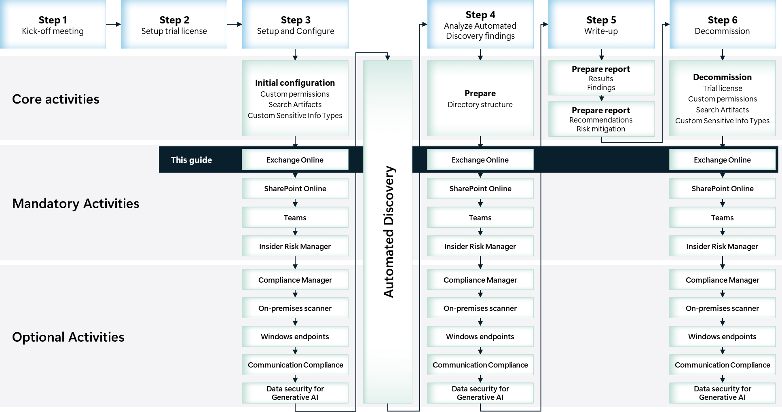

Scoping

In scope
The scope for this activity includes:
- Install and configure Data Loss Prevention for Exchange and Microsoft Purview eDiscovery.
- Gain visibility into hidden data security risks in Exchange Online repositories in use by the customer.

Estimated partner effort
The table below provides a high-level estimate of the partner effort for the activities described in this guide. The numbers provided are to be considered indicative and can change as a result of customization of the delivery schedule and the individual activities.
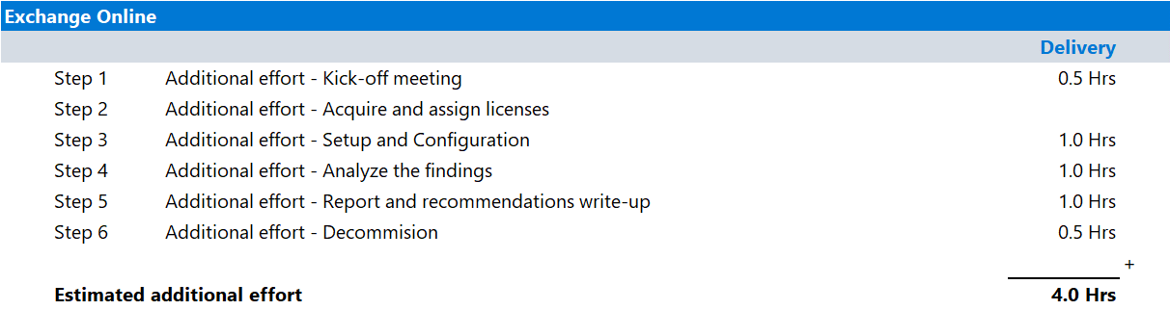

Tools and services used
- The Data Security Check Automated Discovery process leverages Microsoft Purview eDiscovery and Data Loss Prevention for Exchange to discover and report on data security risks in Exchange Online.

Microsoft Purview eDiscovery

Overview
Microsoft Purview eDiscovery can be used to quickly find emails in Exchange mailboxes, documents in SharePoint sites and OneDrive locations, and saved instant messaging conversations.
Microsoft Purview eDiscovery includes the following search capabilities that the Data Security Check will leverage:
- Keyword and condition-based queries, use Boolean operators, wildcards, and property filters.
- Scoping by user, group, or location, target specific custodians or content locations.
- Time range filtering, narrow results to specific date ranges.
- Preview and export, review search results before exporting them for legal or compliance review.

Product information
For detailed information about eDiscovery, refer to:
- Get started with eDiscovery.
- Upcoming changes to Microsoft Purview eDiscovery

Functionality used by the Data Security Check
The Data Security Check will leverage eDiscovery for the discovery of data security risks in:
- Microsoft 365 Exchange Online mailboxes
- Microsoft 365 Exchange Online public folders
- Microsoft 365 Teams saved conversations
- Microsoft 365 groups

Data Loss Prevention for Exchange

Overview
Organizations have sensitive information under their control such as financial data, proprietary data, credit card numbers, health records, or social security numbers. To help protect this sensitive data and reduce risk, they need a way to prevent their users from sharing it with people who shouldn't have it. This practice is called data loss prevention (DLP). With a Microsoft Purview Data Loss Prevention policy, you can identify, monitor, and automatically protect sensitive items across Microsoft 365.
Use a Data Loss Prevention policy to:
- Identify sensitive information across many locations, such as Exchange Online, SharePoint Online, OneDrive for Business, and Microsoft Teams. For example, you can identify any document containing a credit card number that's stored in any OneDrive for Business site, or you can monitor just the OneDrive sites of specific people.
- Prevent the accidental sharing of sensitive information. For example, you can identify any document or email containing a health record that's shared with people outside your organization, and then automatically block access to that document or block the email from being sent.
- Monitor and protect sensitive information in the desktop versions of Excel, PowerPoint, and Word. Just like in Exchange Online, SharePoint Online, and OneDrive for Business, these Microsoft desktop programs include the same capabilities to identify sensitive information and apply Data Loss Prevention policies. Data Loss Prevention provides continuous monitoring when people share content in these Microsoft programs.
- Help users learn how to stay compliant without interrupting their workflow. You can educate your users about Data Loss Prevention policies and help them remain compliant without blocking their work. For example, if a user tries to share a document containing sensitive information, a Data Loss Prevention policy can both send them an email notification and show them a policy tip in the context of the document library that allows them to override the policy if they have a business justification. The same policy tips also appear in Outlook on the web, Outlook, Excel, PowerPoint, and Word.
- View Data Loss Prevention reports showing content that matches your organization's Data Loss Prevention policies. To assess how your organization is complying with a Data Loss Prevention policy, you can see how many matches each policy and rule has over time. If a Data Loss Prevention policy allows users to override a policy tip and report a false positive, you can also view what users have reported.
Data Loss Prevention policies can be created and managed on the Data Loss Prevention page in the Microsoft Purview portal.

Product information
For detailed information on Data Loss Prevention for Exchange refer to:
- Learn about data loss prevention

Functionality used by the Data Security Check
The Data Security Check will leverage Data Loss Prevention for the discovery of data security risks in:
- Exchange Online email in transit (sending & receiving)

Activity details

Step 1 - Kick-off meeting

Guidance
Follow the guidance for the Kick-off meeting provided in the 00-Master Delivery Guide and add the following discussion topics to the meeting:
- Exchange Online data repositories, discuss what types of data is stored in the online repository.
- The tools used by the Automated Discovery process: eDiscovery and Data Loss Prevention for Exchange.
- The types of data security risks that can be identified by the Automated Discovery for Exchange Online.
The 40-Pre-engagement and Kickoff deck contains optional slides with speaker notes that can be used to facilitate the discussion.

Supporting materials
- <40-Pre-engagement and Kickoff deck>

Note
The <40-Pre-engagement and Kickoff deck> is used during the Pre-engagement meeting and the Kick-off meeting. Instructions on how to update the slides are included as hidden slides in the deck.

Pre-requisites
The activities and guidance described in this step complement Step 1 - Kick-off meeting as described in the 00-Master Delivery Guide. The activities should be merged and delivered as one.

Next step
- Return to the <00-Master Delivery Guide> and continue the guidance provided in Step 1 - Kick-off meeting.

Step 2 - Acquire and assign licenses
The required product licenses for this activity are included in the overall Data Security Check trial license that was deployed in Step 2 - Acquire and assign licenses described in 00-Master Delivery Guide. No additional (trial) licenses are required.

Step 3 - Setup and configuration
The Automated Discovery process leverages both eDiscovery and Data Loss Prevention for Exchange to search for data security risks in Exchange Online data repositories.
eDiscovery is used to search for data security risks in data at rest while Data Loss Prevention for Exchange will scan Exchange Online data in transit.
The following paragraphs provide step-by-step instructions to configure eDiscovery and Data Loss Prevention for Exchange to search for Out-of-box Sensitive Info Types, Custom Sensitive Info Types and Stale data in Exchange Online data repositories. Multiple policies will be configured and, where applicable, Sensitive Info Types created previously will be re-used.

Pre-requisites
Prior to starting the activities in this step, the following mandatory Data Security Check activities as described in <00-Master Delivery Guide> should be completed:
- Step 1 - Kick-off meeting
- Step 2 - Acquire and assign licenses
- Step 3 - Setup and configuration

 Important
Both Data Loss Prevention for Exchange and eDiscovery, as utilized by the Data Security Check, depend on Sensitive Info Types to identify data security risks. Before starting this activity, the instructions outlined in Step 3 - Setup and configuration in the 00-Master Delivery Guide should be completed successfully. (i.e., all customer specific sensitive information types configured and available).

eDiscovery Search – Stale Data

Guidance
The Automated Discovery process leverages Microsoft Purview eDiscovery for the discovery of stale data. A new search will be configured and targeted to specific data locations and types in the customer’s tenant. In this section we will describe the steps to create and configure an eDiscovery Search for stale data.

Objective(s)
- Create an eDiscovery Search to be used by the Automated Discovery process to identify stale data in Exchange Online.

Automated Discovery target locations
- Exchange - existing data

Background reading
For more information searching data in Microsoft Exchange Online refer to:
- Keyword queries and search conditions for eDiscovery
- Searchable email properties
- Keyword Query Language (KQL) syntax reference
- Get started with eDiscovery.
- Upcoming changes to Microsoft Purview eDiscovery

[Optional] Instructions - Identify and exclude mailboxes for in-place hold
Exchange Online will create additional copies of mailbox data when organizations use the in-place hold feature. By default, eDiscovery will include the additional in-place hold data repositories in the Automated Discovery process for stale data and this will impact the findings by increasing the number of stale items identified.
Having large numbers of mailboxes configured for in-place hold will eventually invalidate the results.

Note
Excluding the in-place hold mailboxes is an optional activity and should be discussed with your customer before adjusting the search results.

The mailboxes configured for in-place hold can be identified using the following PowerShell command.
get-mailbox
-resultsize unlimited
-SoftDeletedMailbox
| where {($_.inplaceholds -ne $null)
-or ($_.litigationholdenabled -ne $false)
-or ($_.delayholdapplied -ne $false)}
| select displayname, primarysmtpaddress, UserPrincipalName, alias, inplaceholds, litigationholdenabled, delayholdapplied
| export-csv -path C:\temp\LegalHoldUsers.csv -notypeinformation
The illustration below provides an example of the exported *.csv file. The results can be used to exclude mailboxes that are configured for in-place hold from the search results.

Instructions – Create an eDiscovery Search
- Browse to the Microsoft Purview portal at https://purview.microsoft.com/ and log in with Tenant Admin credentials or a user account that is a member of your Data Security Check team and has been assigned the appropriate permissions.
- In the navigation bar on the left side, click on Solutions .
- In the Solutions navigator, click on eDiscovery.
- On the eDiscovery solution card, click on Cases.
- On the Cases page, click on the previously created case DataSecurityCheck-Case.
- On the DataSecurityCheck-Case, on the Searches tab, click Create a search.

Note
Prior to configuring the search, send the previously created <Customer Sensitive> test file as an attachment to another user in the organization. When exporting the search results the files should be included.

- Name your new eDiscovery Search DataSecurityCheck-CS-StaleData-Exchange and provide a meaningful Description.
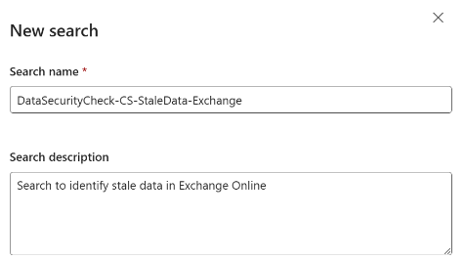
- Click Create.
- On the DataSecurityCheck-CS-StaleData-Exchange page, on the Query tab, on the Data Sources card, click on Add tenant-wide sources.
- On the Manage sources page, select Mailboxes and deselect Sites.
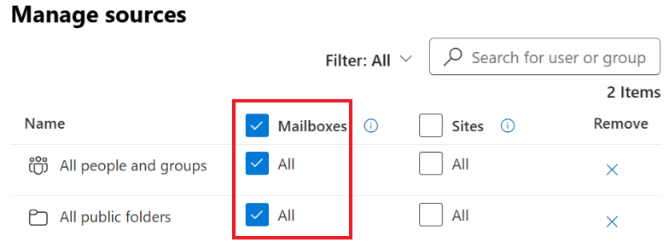
- Click Save.
- On the DataSecurityCheck-CS-StaleData-Exchange page, on the Condition builder tab, click on +Add conditions.
- Click Show more
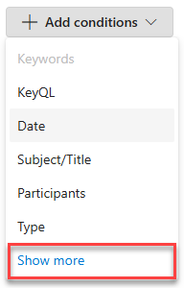
- On the Choose which conditions to add fly-out, below Common conditions, select Date
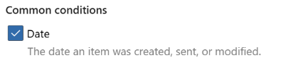
- Below Conditions for Exchange Online mailboxes, select Message kind.
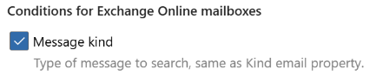
- Click on Apply.
- On the Condition builder tab, next to Enter a keyword or …, click on the Trashcan icon to delete the Keywords condition.
- Next to Date, verify Before is selected and enter a date that meets the criteria defined during the Pre-engagement meeting or Kick-off meeting.

Note
If stale data is defined a “Older than one year”, calculate the date to use by subtracting one year from today. Enter the date for the Condition.

- Next to Search for message type, e.g. email or Teams, click on the Pencil (), to edit the condition.
- On the Message kind fly-out, select Email, Docs, IM, Microsoft teams, Notes and Posts.
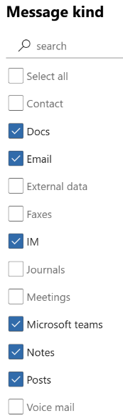
- Click Apply.

Note
eDiscovery Search uses the Keyword Query Language (KQL). For more detailed information, see Keyword Query Language (KQL) syntax reference. Use the information provided to further enhance the search queries..

- On the DataSecurityCheck-CS-StaleData-Exchange page, click on Run query.
- On the Choose search results flyout, below Statistics, select Include categories and Include query keywords report.
- Click on Run Query.

Note
The eDiscovery Search will run after creation. The time it takes to complete the search depends on the amount of data, the complexity of the search query, and the location where the data is stored. Refer to Limits in eDiscovery for details.

eDiscovery Search – Sensitive Keywords

Guidance
This section describes the steps to create a sample search in eDiscovery that will be used to search for specific keywords. For this example, we will use the placeholder sensitive info type called <Customer Sensitive> as the search term.

Important
The sample search configuration should be updated to match customer requirements by updating the query used in the search definition. Refer to the Keyword Query Language (KQL) syntax reference for more information.

Objective(s)
- Create an eDiscovery Search to be used by the Automated Discovery process to identify specific keywords contained in data stored in Exchange Online.

Automated Discovery target locations
- Exchange-existing data

Background reading
For more information refer to:
- Keyword queries and search conditions for eDiscovery
- Keyword Query Language (KQL) syntax reference
- Get started with eDiscovery.
- Upcoming changes to Microsoft Purview eDiscovery

Instructions – create an eDiscovery Search
- Browse to the Microsoft Purview portal at https://purview.microsoft.com/ and log in with Tenant Admin credentials or a user account that is a member of your Data Security Check team and has been assigned the appropriate permissions.
- In the navigation bar on the left side, click on Solutions.
- In the Solutions navigator, click on eDiscovery.
- On the eDiscovery solution card, click on Cases.
- On the Cases page, click on the previously created case DataSecurityCheck-Case.
- On the DataSecurityCheck-Case, on the Searches tab, click Create a search.

Note
Prior to configuring the search, send the previously created <Customer Sensitive> test file as an attachment to another user in the organization. When exporting the search results the files should be included..

- Name your new Content Search DataSecurityCheck-CS-Keywords-Exchange and provide a meaningful Description.
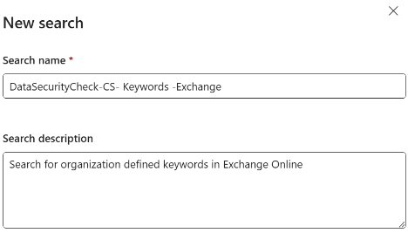
- Click Create.
- On the DataSecurityCheck-CS-Keywords-Exchange page, on the Query tab, on the Data Sources card, click on Add tenant-wide sources.
- On the Manage sources page, below Mailboxes, select All People and groups and All public folders and deselect Sites.

- Click Save.
- On the DataSecurityCheck-CS-Keywords-Exchange page, on the Condition builder tab, click on +Add conditions
- Click Show more
- On the Choose which conditions to add fly-out, below Build KeyQL query, select KeyQL
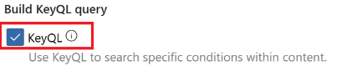
- Click on Apply.
- On the DataSecurityCheck-CS-Keywords-Exchange page, on the Condition builder card, enter the key words or phrases identified by the organization into the Keywords section.

Note
The example query below returns items with words that are near each other, where ‘near’ equals the number of words apart. For example, “Customer” NEAR(5) “Sensitive” returns any item where the word "Customer" is within five words of "Sensitive". If no number is specified, the default distance is eight words.

"Customer" NEAR(5) "Sensitive"
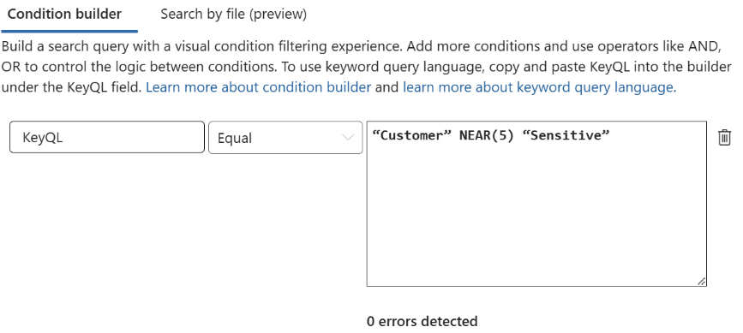

Important
Make sure to replace the placeholder <Customer> and <Sensitive> by search criteria that are relevant to your customer and verify the condition builder shows 0 errors detected.

- On the DataSecurityCheck-CS-Keywords-Exchange page, click on Run query.
- On the Choose search results flyout, below Statistics, select Include categories and Include query keywords report.
- Click on Run Query.

Note
The search will run after creation. The time it takes to complete the search depends on the amount of data, the complexity of the search query, and the location where the data is stored. Refer to Limits in eDiscovery for details.

Note
Carefully inspect the results and check if they meet the expectations for the search query you have defined. If required, you can further optimize the results by adding keywords as described here: Keyword queries and search conditions for eDiscovery. Make sure to update the search results if the query is changed.

Data Loss Prevention for Exchange – Out-of-box Sensitive Info Types

Guidance
This section describes the steps to create a sample Data Loss Prevention policy that uses Out-of-box Sensitive Info Types and pre-trained classifiers to identify potential data security risks.

Important
Replace or update the data types used in this sample policy with data types that meet your customer’s requirements as defined in the Pre-engagement meeting or Kick-off meeting.

Objective(s)
- Configure the Automated Discovery process to search for Sensitive Info Types based on the selection made during the Pre-engagement meeting or Kick-off meeting.

Automated Discovery target locations
- Exchange-data in transit

Background reading
For more information refer to:
- Sensitive information type entity definitions
- Data Loss Prevention policy reference | Microsoft Learn

Instructions – create the policy for Out-of-box Sensitive Info Types
- Browse to the Microsoft Purview portal at https://purview.microsoft.com/ and log in with Tenant Admin credentials or a user account that is a member of your Data Security Check team and has been assigned the appropriate permissions.
- In the navigation bar on the left side, click on Solutions
- In the Solutions navigator, click on Data loss prevention.
- On the Data Loss Prevention solution card, click on Policies.
- On the Policies page, click + Create policy.
- On the Choose what type of data to protect page, select Data stored in connected sources.
- Click Next.
- On the Start with a template or create a custom policy page, select a policy template relevant to your customer.

Note
Policies have a strong dependency on the region the customer is operating in, if the customer is unfamiliar with local regulations, it is advised to select a generic template. For example for customers based in the United States of America, choose Privacy à U.S. Personally Identifiable Information (PII) Data Enhanced and for customers located in the European Union, choose Privacy à GDPR Enhanced

- Click Next.
- Type DataSecurityCheck-DLP-OutOfBox-Exchange as the name of the new policy and provide a meaningful Description.
- Click Next.
- On the Assign admin units page, click Next.
- On the Choose where to apply the policy page, enable Exchange email and disable all other locations.
- Click Next.
- On the Define policy settings page, select Create or customize advanced DLP rules.
- Click Next.
- On the Customize advanced DLP rules page, expand Low volume of content detected... by clicking on the arrow()
- Click on the Pencil () to Edit the rule.

Instructions - Update the advanced policy settings
- Under Conditions, remove the Content is shared condition by clicking on the Trashcan icon ().
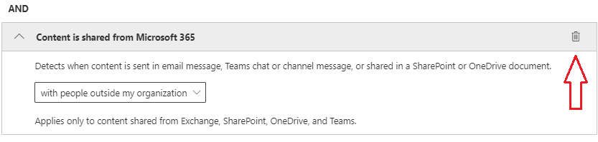
- Under Actions, remove any actions that might be listed by clicking on the Trashcan icon ().
 Important
Carefully check and verify if all actions are removed from the policy. Failure to do so will impact the user experience.

- Under User notifications set the slider to Off to disable notifications to content owners and/or users.
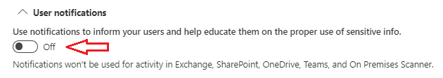
- Under Incident reports verify the sliders are set to Off.
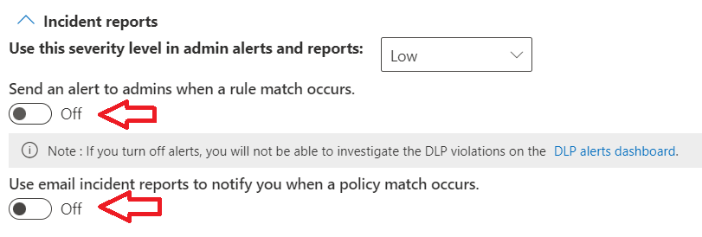
- Click Save.
- Repeat the Steps described above in Instructions - Update the advanced policy settings for any other built in DLP rules (e.g., High volume of content detected….)
- Click Next.
- On the Policy mode page, select Turn the policy on immediately.
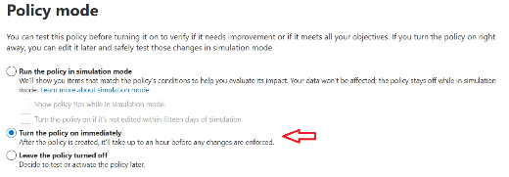
Note
It can take up to one hour for the new policy to go into effect.
- Click Next.
- Review your settings and then click Submit.
- Click Done.

Important
The order of creation determines the priority of policies, each policy is automatically assigned an incrementing priority number when created. The policy's priority numbers, with 0 being the highest priority, are used to determine which policies will be applied in case there are multiple matches .
For policies that already exist prior to the start of the Data Security Envisioning Workshop (eg. the “Default Office 365 DLP Policy”) you need to check and possibly change the policy priority to assure the newly created policy will apply. For more information refer to Data Loss Prevention policy reference | Microsoft Learn.

Data Loss Prevention for Exchange – Custom Sensitive Info Types

Guidance
This section describes the steps to create a sample Data Loss Prevention policy to discover Custom Sensitive Info Types that were configured to match specific customer requirements. The policy will look for the custom information types that were previously configured in data that is in transit.

Objective(s)
- Configure the Automated Discovery to search for a customer specific search term based on the selection made during the Pre-engagement meeting or Kick-off meeting.

Automated Discovery target locations
- Exchange-data in transit

Background reading
For more information refer to:
- Learn about sensitive information types.

Instructions - create the policy
- Browse to the Microsoft Purview portal at https://purview.microsoft.com/ and log in with Tenant Admin credentials or a user account that is a member of your Data Security Check team and has been assigned the appropriate permissions.
- In the navigation bar on the left side, click on Solutions
- In the Solutions navigator, click on Data loss prevention.
- On the Data Loss Prevention solution card, click on Policies.
- On the Policies page, click + Create policy.
- On the Choose what type of data to protect page, select Data stored in connected sources.
- Click Next.
- On the Start with a template or create a custom policy page select Custom à Custom policy.
- Click Next.
- Type DataSecurityCheck-DLP-Custom-Exchange as the name of the new policy and provide a meaningful Description.
- Click Next.
- On the Assign admin units page, click Next.
- On the Choose where to apply the policy page, enable Exchange email and disable all other locations.
- Click Next.
- On the Define policy settings page, verify Create or customize advanced DLP rules is selected.
- Click Next.
- On the Customize advanced DLP rules page, click +Create rule.
- Below Name enter DataSecurityCheck-DLP-CustomRule and provide a meaningful Description.
- Below Conditions, click +Add condition and select Content contains from the drop-down list.
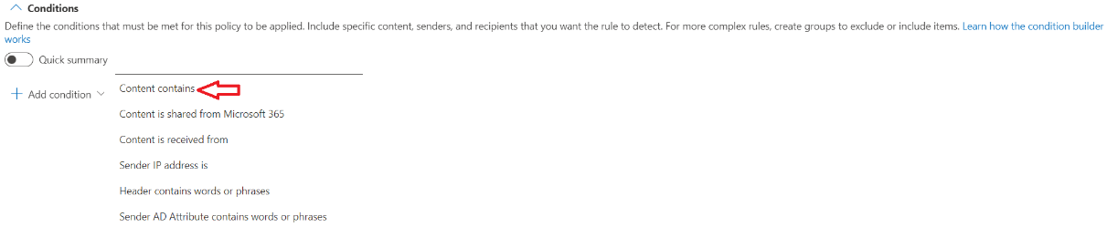
- Below Group operator, verify Any of these is selected.
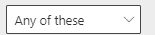
- Below Content contains, click Add and select Sensitive Info Types from the drop-down list.
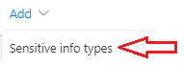
- On the Sensitive info types page, select all Custom Sensitive Info Types that were identified by you and your customer during the Pre-engagement meeting or Kick-off meeting and were previously created.

Note
The previously created Custom Sensitive Info Types can be easily identified by sorting the view on the <Publisher> name or by searching for <DataSecurityCheck->.
If additional sensitive information types are relevant to the customer add them at this time.

- Click Add.
- On the Create rule page, below Evaluate predicate for (available in Exchange workload only) verify Message or attachment is selected.
- Below User notification verify Use notification .. is set to Off.
- Below Incident Reports, below Send an alert to admins when a rule match occurs, set the switch to Off.
- Below Incident reports, below Use email incident reports to notify..., set the switch to Off.
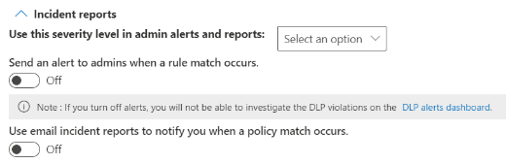
- Leave all other settings to default.
- Click Save.
- On the Customize advanced DLP rules page, click Next.
- On the Do you want to turn on… page, select Turn the policy on immediately.
Note
It can take up to one hour for the new policy to go into effect.

- Click Next.
- Review your settings and then click Submit.
- Click Done.

Next step
- Return to the <00-Master Delivery Guide> and continue the guidance provided in Step 3 - Setup and configuration.

Step 4 - Analyze the findings
In this step the partner will, together with the customer’s tenant / compliance administrator, analyze all logs, information, and reports generated by the different Data Security Check tools and services. This section describes the additional steps required to prepare and analyze the results from the Automated Discovery for Exchange Online.
It is recommended to do a two-step analysis of the logfiles, reports, and findings:
- Quick scan. By using the various dashboards and preview views, you will be able to identify common patterns and/or trends that need further investigation and can serve as an example of data security risks. Look for “most impactful” events related to important people within the organization, high volumes of documents related to a specific business process, Personally Identifiable Information (PII), etc.
- Detailed analysis using exported log and report files for the various services will allow for further investigation of previously identified data security risks and events flagged during the quick scan. Aim at determining the impact and risk and consider possible solutions for mitigation. During this detailed analysis you are advised to leverage the insights of the customer team because they will know what and who to look for. To rule out “false positives” you are advised to do further investigation of all the events that will be included in the final closeout presentation at the end of the engagement.

 Important
It is important to stay within the scope of this activity while analyzing the findings and identified data security risks. Unless exceptional risks are identified that require immediate action, the activities for this step should be limited to analysis and not extend to mitigation or corrective action. If corrective action or mitigation is required, this should be discussed with and approved by the customer prior to engaging on these out-of-scope activities. The objective of the Data Security Check is to highlight data security risks to the customer’s organization and to understand, learn, and advise on what can be done to mitigate these risks.

Pre-requisites
Prior to starting the activities in this step, the following mandatory Data Security Check activities as described in <00-Master Delivery Guide> should be completed:
- Step 1 - Kick-off meeting
- Step 2 - Acquire and assign licenses
- Step 3 - Setup and configuration
- Step 4 - Analyze the findings

Prepare for analysis – eDiscovery Search

Guidance
Follow the steps outlined in this section to generate and export reports related to the eDiscovery Search.

Objective(s)
- Update the search results to include data that was created over the time the Automated Discovery was active.
- Generate and export the search reports.

Background reading
For more information refer to:
- Evaluate and refine search results in eDiscovery

Instructions
- On the local workstation, if not already done, extend the previously created directory structure by creating the \DataSecurityCheck\ExchangeOnline folder.
- Browse to the Microsoft Purview portal at https://purview.microsoft.com/ and log in with Tenant Admin credentials or a user account that is a member of your Data Security Check team and has been assigned the appropriate permissions.
- In the navigation bar on the left side, click on Solutions.
- In the Solutions navigator, click on eDiscovery.
- On the eDiscovery solution card, click on Cases.
- On the Cases page, click on the previously created case DataSecurityCheck-Case.
Update search results
- On the DataSecurityCheck-Case page click on the first search related to Exchange in the list.
- On the <SearchName> page, on the Statistics tab, inspect the Last run on date.

- If the Last completed date is more than two to three days ago, the search results should be updated by clicking Regenerate view.
- On the Regenerate statistics view flyout, select Include categories and Include query keywords report and click Run query.
- In the search trail, click on Searches to return to the DataSecurityCheck-Case page.
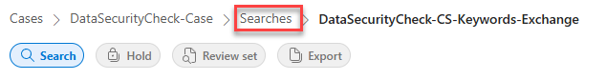
- Repeat the Update search results steps for all other Exchange-related searches that are out of date.

Note
Updating the search results depends on the amount of data in the customer’s tenant and can take significant time to run. If possible, try to schedule re-running the search in advance.

Search statistics
- On the DataSecurityCheck-Case page page, search for DataSecurityCheck- and click the first search related to Exchange in the list.
- On the <SearchName> page, click on Statistics.
- On the <SearchName> page, on the Search statistics tab, create a screenshot of the Search Summary.
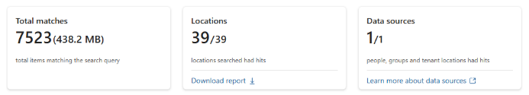

Note
Refer to Use Snipping Tool to capture screenshots for guidance on taking screenshots.

Note
Before saving the screen shot, it is advised to edit the image and add a descriptive header, this will make it easier to recognize the screenshots when inserting them in the <41-Close-out deck>. For example:
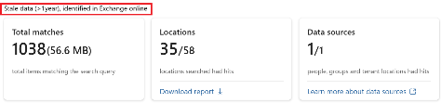

- Save the screenshot as Summary-<Search Name>.jpg to the \DataSecurityCheck\ExchangeOnline folder on your local workstation.
Top 100 locations
- On the <SearchName> page, on the Statistics tab, on the Top data sources card, click View top 100.
- On the Data source page, create a screenshot of the First 10 rows.
- Save the screenshot as Top10-<Search Name>.jpg to the \DataSecurityCheck\ExchangeOnline folder on your local workstation.
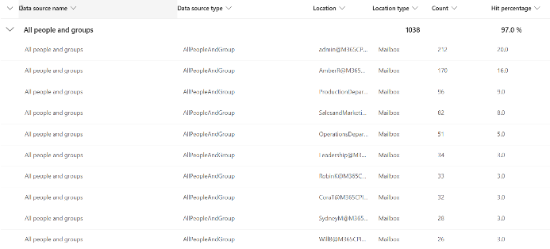
- On the bottom of the Data source page, click on Download report.
- Save the report as Top100-<Search Name>.csv to the \DataSecurityCheck\ExchangeOnline folder on your local workstation.

Note
By default, all export files are named <data_sources_report.csv>. Because you will be exporting a file for every search you have created, change the filename to include the name of the search.

- Repeat the Search statistics and Top 100 locations steps for all other Exchange-related searches.

Prepare for analysis – Data Loss Prevention for Exchange

Guidance
Follow the steps outlined in this section to generate and export reports related to Data Loss Prevention for Exchange.

Note
Reports for Data Loss Prevention for Exchange will list the subjects of email messages that triggered the policy. If this is unwanted from a privacy or confidentiality perspective, it is recommended to obfuscate the data before analysis.

Objective(s)
- Generate and export the Data Loss Prevention policy matches reports from Activity Explorer.

Background reading
For more information refer to:
- Get started with Activity explorer

Instructions
- Browse to the Microsoft Purview portal at https://purview.microsoft.com/ and log in with Tenant Admin credentials or a user account that is a member of your Data Security Check team and has been assigned the appropriate permissions.
- In the navigation bar on the left side, click on Solutions.
- In the Solutions navigator, click on Information Protection.
- On the Information Protection solution card, expand Explorers.
- Below Explorers, click on Activity explorer.
- Click on the Selected filter set dropdown and select Files containing sensitive info types.
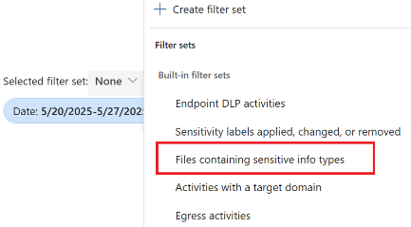

Note
By default, the dashboard shows one week of data; to view the findings of the Automated Discovery the date range should be updated to include the results of the Automated Discovery.
- On the filter option row, click on Date.
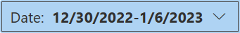
- In the Date dropdown, update the Start date and End date to include the period the Automated Discovery has been active.
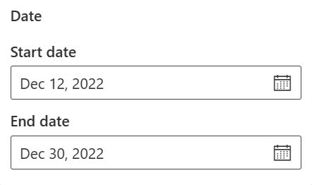
- On the filter options row, click on Location, select Exchange, leave all other selections unchecked.
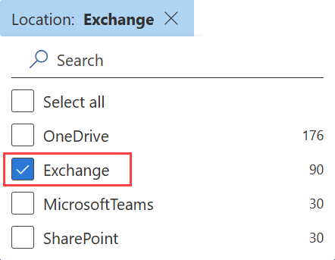
- Above the Activity details list, click Customize columns.
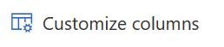
- In the Customize columns pane, check Sensitive info type and Sensitive info type count to add them to the currently selected items. Leave all other selections as-is.
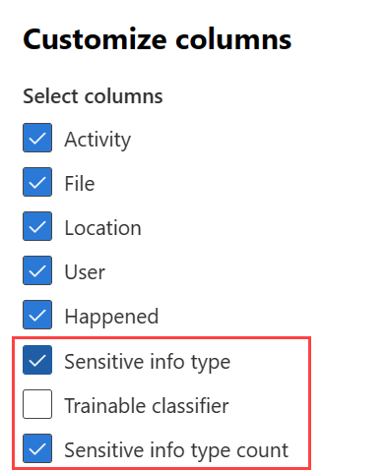
- Click Apply.
- Above the Activity details list, click on Export.
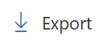
- On the browser download options choose Save as and save the csv file to the
\DataSecurityCheck\ExchangeOnline folder on your local workstation. If the file automatically downloaded, you may need to retrieve the Activity Explorer – Microsoft Purview.csv file from your downloads folder.

Analyze results - eDiscovery Search

Guidance
The results for each search are accessible through the Microsoft Purview portal and as screenshots exported to the \DataSecurityCheck\ExchangeOnline folder (see paragraph 2.4.1-Prepare for analysis – eDiscovery Search). The contents of these files should be analyzed, and where applicable, copied to the placeholder slides in the closeout-presentation <41-Close-out deck>.

Filename: Summary-<Search Name>.jpg
Location | \DataSecurityCheck\ExchangeOnline/
Contains | Summary providing a high-level overview of:  - Total items matching the search query  - Number of locations with content matching the search query.  - Number of data sources with content matching the search query.
Usage | Provides high level overview of findings.
Use in closeout deck? | YES
Instructions | - Copy the saved screenshot to the appropriate slide(s) in the 41-Close-out deck.  - Provide relevant information about the search in the slide title.
Sample illustration | 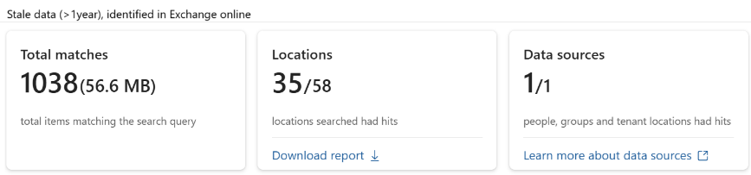  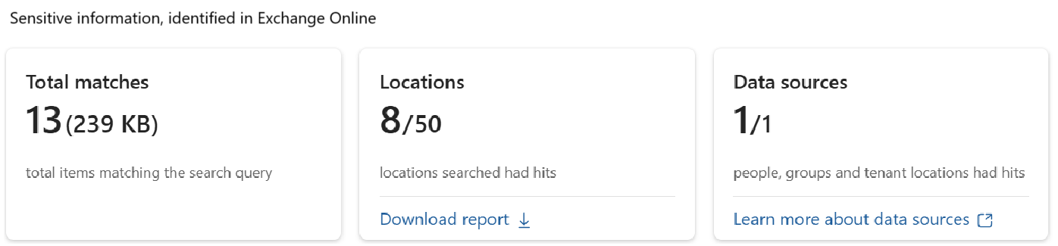

Filename: Top 10<Search Name>.jpg
Location | \DataSecurityCheck\ExchangeOnline
Contains: | Overview of top locations for identified content  - Location  - Location type  - Number of items  - Hit percentage
Usage | Overview of top locations.
Use in closeout deck? | YES
Instructions | - Copy the saved screenshot to the appropriate slide(s) in the <41-Close-out deck>.  - Provide relevant information about the search in the slide title.
Sample illustration | 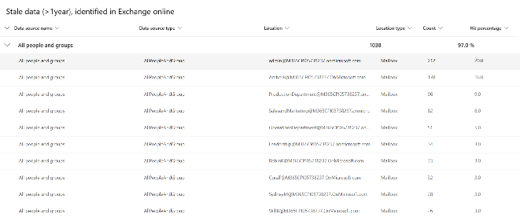  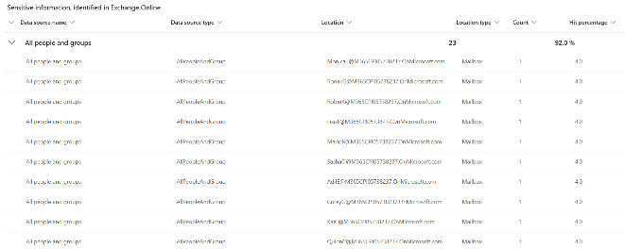

Filename: Top100-<search results>.csv
Location | \DataSecurityCheck\ExchangeOnline\
Contains | Detailed inventory of all search locations and identified risks  - Search location and location type  - Detailed information about every item identified.
Usage | In-depth investigation
Use in closeout deck? | NO
Instructions | - Import the export file into Excel following the instructions in the appendix in the <00-Master Delivery Guide>.  - Analyze and create pivot tables to investigate
Sample illustration | N.A.

Analyze the results - Data Loss Prevention for Exchange

Guidance
The Data Loss Prevention for Exchange results are exported to a single file. The contents of this file should be analyzed and copied to the placeholder slide in the closeout-presentation <41-Close-out deck>.

Filename: Activity explorer – Microsoft Purview.csv
Location | \DataSecurityCheck\ExchangeOnline
Contains | Overview of all sensitive data that was sent or received through Exchange Online (data in transit), provides details on:  - Date and time of discovery  - Sensitive Info Types that were discovered  - Name and location of the file  - Account who last modified the data  - DLP Policy and rule that triggered the identification

Usage #1 | Provide a top 10 overview of most detected Sensitive Info Types
Use in closeout deck? | YES
Instructions #1 | - Import the export file into Excel following the instructions in the appendix in the <00-Master Delivery Guide>.  - Create a pivot table matching the definition depicted in the illustration below.  When creating the closeout presentation, copy the pivot table to the appropriate slide in the deck.
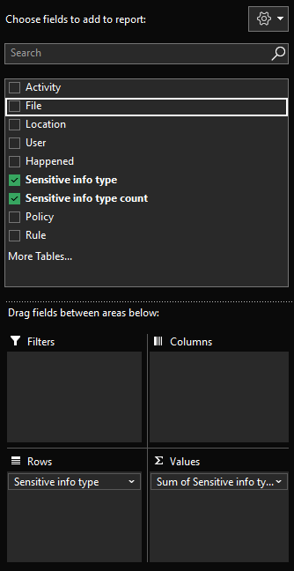
Filters: Empty
Columns: Empty
Rows: Sensitive Info Type
Ʃ Values: Sum of Sensitive Information Count
Sort: Z-A Sum of Sensitive information count
Sample illustration #1 | 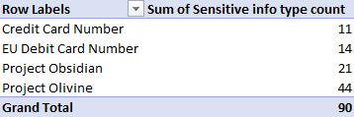

Usage #2 | Provide a top 10 of users who send data that imposes privacy and regulatory risks to the organization.
Use in closeout deck? | YES
Instructions #2 | - Import the export file into Excel following the instructions in the appendix in the <00-Master Delivery Guide>.  - Create a pivot table matching the definition depicted in the illustration below.  - When creating the closeout presentation, copy the pivot table to the appropriate slide in the deck.
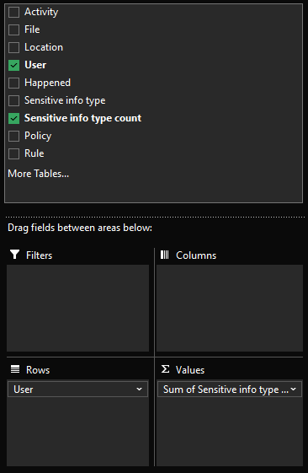
Filters: Empty
Columns: Empty
Rows: User
Ʃ Values: Sum of Sensitive information count
Sort: Sum of Sensitive information count
Sample illustration #2

Next step
- Return to the <00-Master Delivery Guide> and continue the guidance provided in Step 4 - Analyze the findings.

Step 6 - Decommission

Guidance
The final activity for the Automated Discovery for Exchange Online activity is to decommission the services and tools used for this activity.

Objective(s)
The objectives for this activity are:
- Decommission the services that were installed to support the Automated Discovery for Exchange Online.

Deliverable(s)
For this activity, the following deliverables have been defined:
- All tools and services used during the Automated Discovery for Exchange Online are decommissioned.
- All custom configuration artifacts are removed from the customer’s tenant.

Instructions – Delete eDiscovery Search
Individual eDiscovery Searches cannot be deleted from an eDiscovery case, refer to the instructions in the <00-Master Delivery Guide> to delete the case from the Microsoft Purview eDiscovery.

Instructions – Delete custom Data Loss Prevention policies
- Browse to the Microsoft Purview portal at https://purview.microsoft.com/ and log in with Tenant Admin credentials or a user account that is a member of your Data Security Check team and has been assigned the appropriate permissions.
- In the navigation bar on the left side, click on Solutions
- In the Solutions navigator, click on Data loss prevention.
- On the Data Loss Prevention solution card, click on Policies.
- On the Policies page, Search for previously configured Data Loss Prevention Policies related to the Data Security Check by typing DataSecurityCheck- in the search box.
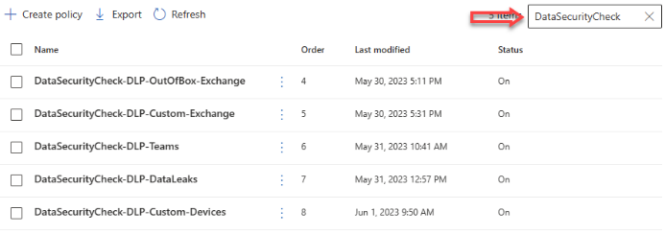
- Select the Data Loss Prevention Policies previously created for Exchange.
- Depending on the number of policies selected, click Delete policy or Delete policies.
- On the Warning page, click Yes.

Next step
- Return to the <00-Master Delivery Guide> and continue the guidance provided in Step 6 - Decommission.

